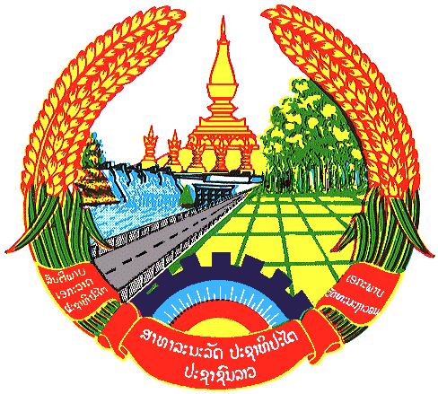

Statement by the delegation of the Lao PDR
At the 26th Session of UPR Working Group
Geneva, 31 October 2016 – 11 November 2016
----------------

Review of the Bolivia Republic of Venezuela : 1 November 2016, at 9:00 - 12:30 hours

Mr. President,

The Lao delegation warmly welcomes the distinguished delegation of the Bolivia Republic of Venezuela to the 26th Session of the UPR Working Group and would like to thank for the comprehensive presentation on the promotion and protection of human rights in the country.

My delegation takes note with appreciation Venezuela’s strong commitment towards promotion and protection of human rights by approving the National Human Rights Action Plan for 2015- 2019, We commend that Venezuela has ratified International Convention on the Right of Persons with Disability and its protocol, as well as amending and adopting number of domestic acts relating to human rights in order for creating favourable conditions for people to enjoy their fundamental rights and freedom. Lao PDR also commends Venezuela’s active participation in the work of the Human Rights Council, as well as engaging with other human rights mechanisms and treaty bodies.

My delegation wishes to make following recommendations:

- To continue in your effort to create human right training for national public defence personal;
- To continue updating curricular content and methods, guaranteeing appropriate educational contents to ensure optimal teaching, and
- To continue expanding excellent policies to promote cultural rights through the “Cessar” Rengifo National Theatre Movement.

We wish Venezuela every success in its Second Cycle of UPR.

I thank you, Mr. President

